**What’s due:**

Submit an advertising analysis **before the live class in week 6**. Suggested length is five pages, but should not exceed ten pages, single-spaced, 12-point font.

Use Google analytics to analyze the data to identify patterns and opportunities. Your goal is to recruit the best United States students, measured by GMAT scores, but you are limited to a budget of $100,000. The budget must cover advertising costs, but no Whitman administration costs.

**Outline and grading criteria:**

1. What were the time frames for each marketing campaign? How much was spent on each campaign? What was the effectiveness of previous campaigns? (40%)  a. whitman.syr.edu

The timeframe for the Whitman.Syr. Edu campaign was February 26th, 2011 through August 23rd, 2011. If we look at the data by month during this time period we can see that there was a gradual growth in spend during February and March, and then there was a more stabilized approach from April through August.

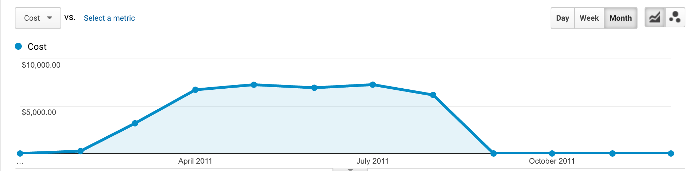

There were multiple campaigns under the Whitman.Syr.Edu account during this specific time period, but for the purposes of this assignment, we will focus on the aggregate marketing metrics across the two of them, but focus on site behavior specific to Whitman FT MBA, which was the campaign with the largest proportion of the activity during this time period.

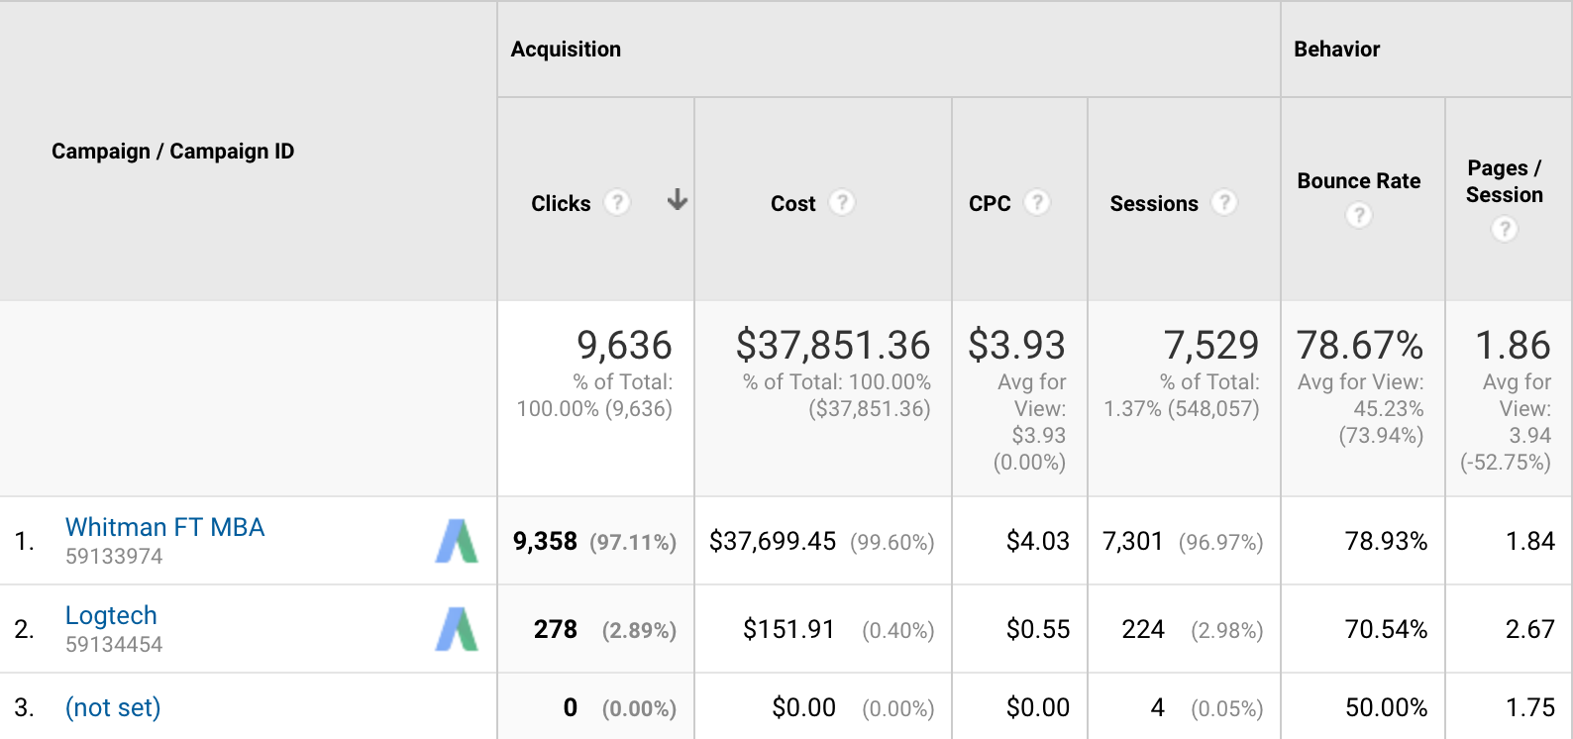

The total amount spent on this ‘Whitman FT MBA’ campaign was $37,699.45, but we’ll filter in the additional cost and site metrics from Logtech to allow for more simplified analysis, so the total cost of advertising during this period was $37,851.36. We registered 9.63k clicks, at an average cost of $3.93 per click. Depending on the medium of advertising, whether this was exclusively online display ads, or google search results, our main KPI will be the total amount of clicks. The Cost per Click – Calculated by Total Cost/Total Clicks is directly influenced by this click count. Because this is an awareness campaign with no second click/conversion objective, we can discern that this is likely a branding effort to raise awareness about the school, and particularly about the MBA Program. Being as it is, our ability to determine success would best be measured by looking at general KPIs across the digital advertising realm- How many clicks did we drive? At what cost? What was the average CPM (Cost per Thousand Impressions- Calculated as Cost/Impressions *1000)? How many people saw our ads (reach/unique reach). I’d argue that the importance of a branding campaign is to get in front of as many eyeballs as possible. Attribution is already going to be limited unless there’s a conversion/enrollment point on the site, so we’d have to use logic to deduce our cost of goods sold during a particular time, and how it relates to upticks in enrollment across the program during a period after the campaign took place. Because this would require additional data and probabilistic modeling, our click count and the corresponding traffic to the site will be our main KPIs (key performance indicators) here. Note that clicks are generally higher than sessions due to bounces before page load, either due to slow load times, or misclicks. Adwords also has an algorithm used to prevent fraudulent bot behavior that could cost advertisers money. The effectiveness of this specific campaign would have to be measured against internal benchmarks. What was the initial goal? If we drove 7529 total people to the website, included returning visitors, we drove someone to the site for $5. What would be useful if we could tie enrollments into click through conversions on the site. That would help us better determine RoAS (return on ad spend).

1. Identify the key aspects of a United States campaign for next year (20%) a. In which geographic region would you advertise? Which states? Why? b. What key words would you use? Why? c. Which days of the week and what time of day would you advertise? Why?

Location targeting is one of the most powerful tools in digital advertising, and advertising in general. Geotargeting is the idea of an imaginary fence around a location, whether it be a Country, DMA, State or set of latitudes and longitudes. The idea is to limit your advertising towards locations where people are most likely to engage, and be influenced by your ad. In this setting, where we are advertising for a school, logic assumes that people within a closer proximity to the school will feel a greater connection, or a sense of community to the University.

For a United States campaign, we can look at the location data from this campaigns’timelines to make assumptions about the most engaged audience, and best determine where to spend our money. 78.76% of traffic came from within the United States, so it makes sense that our main focus is in the US.

Looking at our heatmap, we can see that logic prevails, and that most of the site traffic during this time period came from the State of New York, and was skewed more towards Northeastern states in general, with the exception of California and Texad.

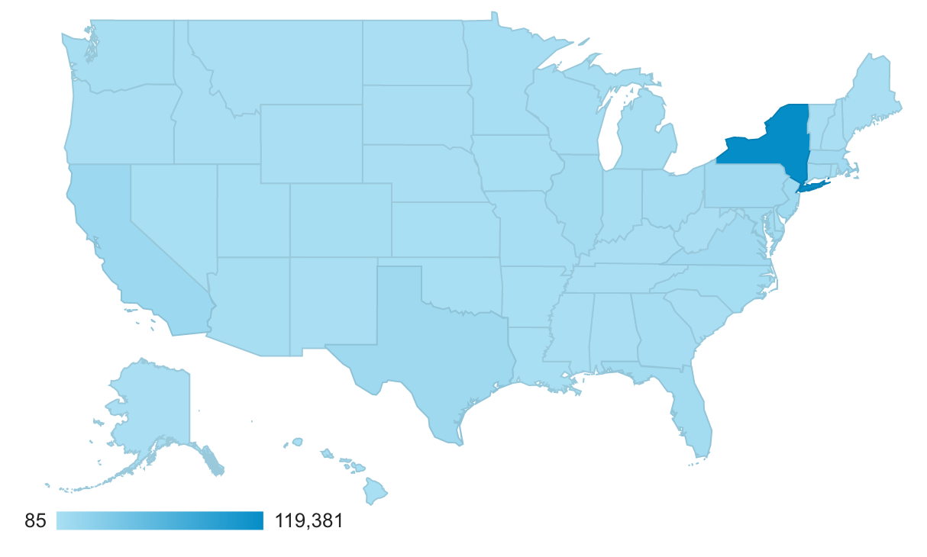

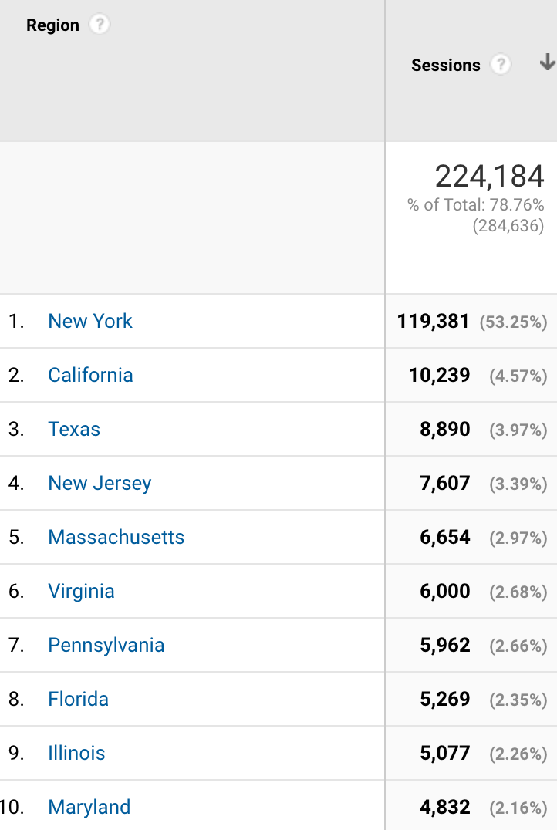

So our main point of emphasis should be to eliminate some of the areas that generally aren’t great traffic drivers. I would go as far as to eliminate everything besides the state of New York from my efforts, and narrow in there. We can see that most of the traffic from New York state comes from within the cities of Syracuse and New York City.

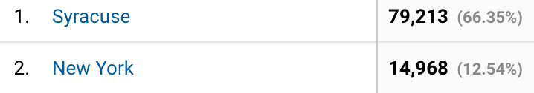

There wasn’t an emphasis on keyword targeting in this campaign, so my instinct leads me to believe that this was more of a display campaign than it was search. That being said, most of the Google Search campaign was directed at a single keyword, which was ‘mba’. Because this marketing push is apparently tailored towards the full time MBA program, I would use language/keywords that draw people in. MBA is a broad search term, and what would perhaps expand our reach would be to offer some more specificity into our program. Something about a ‘waiver’ or ‘online’ would definitely help to increase our share, and draw more engagement, but that would only apply if we were pushing the school as a whole, and not a particular program. Using the word ‘top’, or something along those lines, as a definer of the school would also help to enhance query results. People are interested in going to an ‘accredited’ school that carries weight. By tailoring our keywords around competitive advantages we will notice that we appear in more queries, and will likely see a corresponding lift in traffic/engagement.

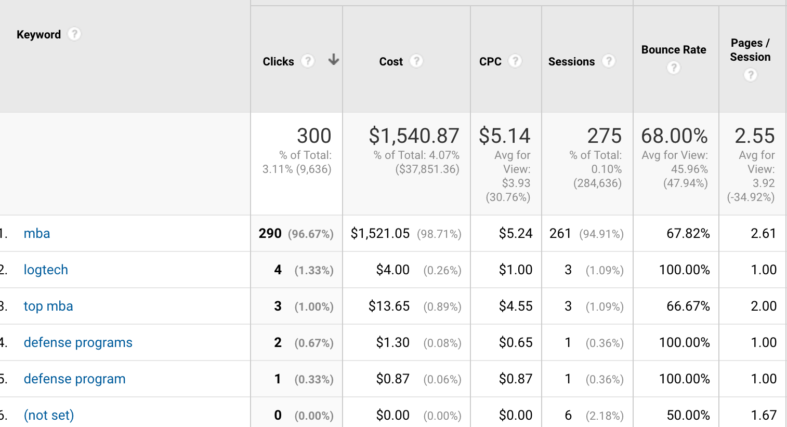

Looking at this same timeframe that this campaign took place, we can try to deduce potential dayparts, which would tailor our ads to be seen during specific hours, and days of the week where activity is high.

1. Identify the costs for your advertising campaigns (10%) a. By region  b. By degree program

As noted earlier, I would heavily skew my budget towards New York, particularly because this is a full time program marketing effort, so I’m probably going to draw a lot more enrollment from in state people due to proximity and the cheapness of tuition as opposed to alternative out of state options. I would spend atleast 90% of by budget in the state of Newyork, with most of that tailored towards people within the cities of New York and Syracuse. Because I only analyzed the full time campaign, I would counter the notion of spending this much money on recruiting ground students. I think the way of the future is online schooling, where students have flexibility to work and pursue a higher education. That being said, I would need to know more about the finances behind each option, and which type of student makes the University more money in the long run. My natural inclination is that people would be more drawn in by the idea of distance learning, and particularly the idea of a GMAT waiver, which eliminates the need to take time off of work to study, etc.. The convenience of this option far exceeds the former, and would be where I would personally spend most of my advertising budget.

1. How would you measure performance of your decisions after implementation? (20%)

As mentioned earlier, there is a disconnect between some content verticals and the ability to directly attribute marketing efforts towards results. In this case, our number one goal would be to increase enrollment. Unless we have a direct enrollment option that is pixeled as a conversion point on our website, we won’t be able to determine true RoAS. That being said, we would want to look at some of the other vanity metrics to determine that we are completing the step directly before that to the best of our abilities. These vanity metrics include clicks, CPC, CPM. Average time on site, Pages per session, and bounce rate, among others. I would want to know that I am spending money essentially educating and branding the program that I am advertising for, even if I couldn’t tie it in with a measurable revenue action. We could determine our success by measuring the quality of the audience that we are gaining from our efforts.

1. What other factors or considerations are important? What other data would help in  developing an Internet advertising strategy, if you could collect it? (10%)

I think that Gender and age are big ones that are normally tracked that we don’t have access to view within GA. These are usually identifiable pieces of information across devices that could better help in the optimization process. Again, the idea of tracking events/goals would be the most beneficial segment of data.If we had some type of form fill on the site, we could use our CRM to deterministically hit an audience that showed a high level of engagement on our site – This is a form of retargeting that generally hits the most valuable audience there is – General retargeting of site visitors also works well if there is an action on the page we are trying to drive. Return users are more valuable than new users (new users are gained through prospecting). Return users essentially weeds at the portion of the target demo that wasn’t exactly intrigued with what they saw during the first visit.